how to use graphics in c language

jo hamari console hota hai wo text mode me work karata hai jiase es me bahot sare block bane h or har ek block ko koe character chahiye or agar hame koe circle banana hua toh hum ek smooth circle bana nhi payege es ke leye hame chahiye toh hum output screen ko interprate dusari tarah se karege jis me bahot sare dots hoge like pixels , ab hum es ke circle bana sakate hai kuch pixels ka colour change kr ke or es screen ko hum graphic mode screen kahate hai

ab yeh screen taeyar karane ka kam ek driver ka hota jise kahate hai hum graphics driver , ab es ke leye ek library banae gayi hai jis ke andar graphical kam karane ke leye bahot sare predefined function defined hai or un se ke decleration contain wali file banae hai jis kahate hai

<graphics.h>

yeh wo header file hai jis me bahot sare predefined functions hai or bahot sare macrons jis ki help se hum graphical programming kr sakate hai

pr but etana hi kafi nhi hai pahale hame text mode se screen ko graphics mode me switch karwana hoga

or text mode se graphical mode me switch karwane ke leye ek function hota hai

initgraph();

es function me argument me 3 chije pass hoti hai pahala graphics driver

us ke leye hum ek variable banayegeg jis ki value tamal graphics me se us ka representative no. hoga yani jitane bhi graphic no. hai un ko ek unique no. se denote kiya jata hai

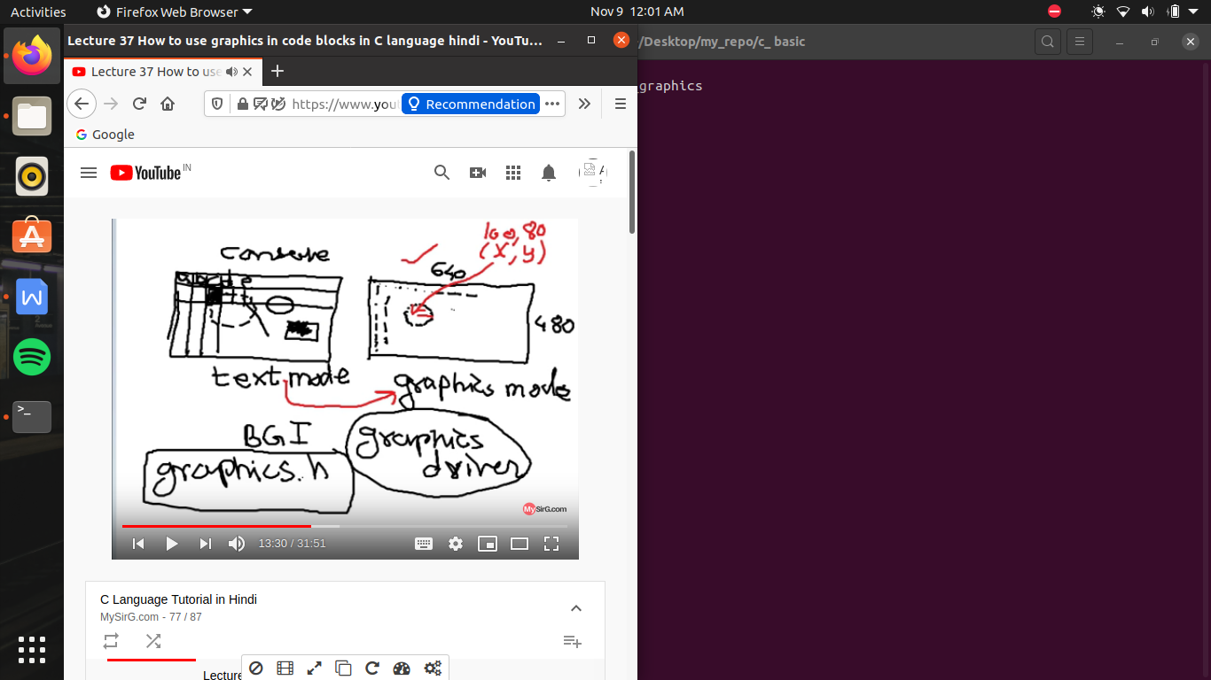

now in gcc compiler and in code block , doesn’t have any graphics based library, so when we include<graphics.h>

it yield error so me want graphic library as well as header file